Test Strategy

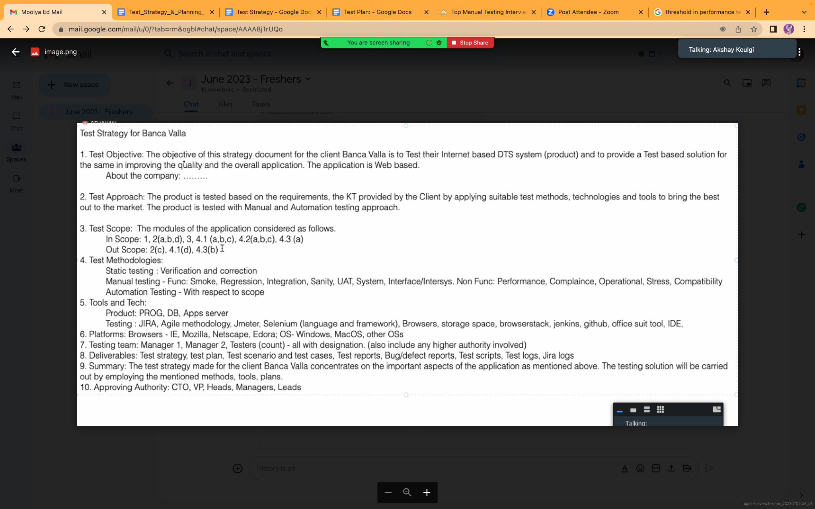

Test Objective:

* Objective of this test document for the client Bunca valla is to test their internet based DTS(product),using Static and a few manual testing methods.
* To provide test based solutions and improve the quality of web applications.

Test Approach:

* The product is tested based on the requirements, the KT provided by the client starting with static testing and test scenarios to bring out best practices.

Test Scope:

* Admin: set access level permissions to other users.
* Manager for regular users: provide access
* Manager for occasional user:customer profile management
* End user: Profile -orders
* Settings:register/login/logout

Test methodologies:

* Understanding the requirements.
* Static testing: Verification and corrections
* Manual testing:

1)Functional Testing: Smoke,Integration Testing,Interface/intersys.

2)Non-Functional Testing:Compatibility,Performance.

Tools and Technologies:

* Product :PROG,DB,Apps Server.
* Testing:JIRA,Agile,Jmeter,Storage space,Office suite tool.

Platform and Coverage:

* Browser -IE,Mozilla,Netscape,Edora.

Testing Environment:

* Development & Testing Environment.

Deliverables: Test strategy,Test Plan,Test Scenarios,Test cases,Test Reports,Bug Report,Jira logs.

* Test Plan Timeline from 19-07-2023 to 2-08-2023.

Testing Team:

* Manager1,Manager2,Testers(count)-with all designation.

Summary:

* The Test Plan made for Banca valla concentrates on admin activities, few Manager activities(regular and occasional user),End user activities,and few Setting functions.

Approving Authority:

* Product owner,Business analyst, Test Manager,Test Leads.

